Stretch Goal 1: evidence of using functions

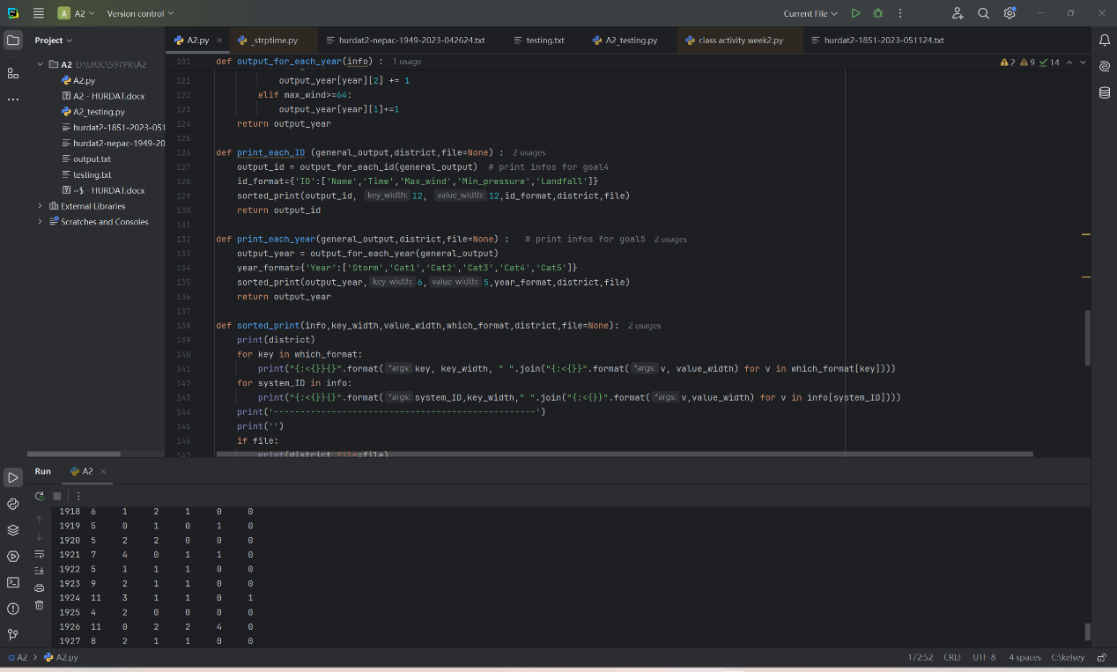

Stretch Goal 2: Evidence of using Break Point to verify if I was coding in a memory efficient way

